Project Design Phase-II
Technology Stack (Architecture & Stack)

Date | 05 October 2026
Team ID | SWTID-2026-9175
Project Name | Auto Ticket Classification using Flow Designer
Maximum Marks | 4 Marks

Technical Architecture:
The Deliverable shall include the architectural diagram as below and the information as per the table1 & table 2
Architecture – Auto Ticket Classification using Flow Designer
Overall flow: Student / teacher creates ticket → Flow Designer classifies it → table updated → email sent to caller.
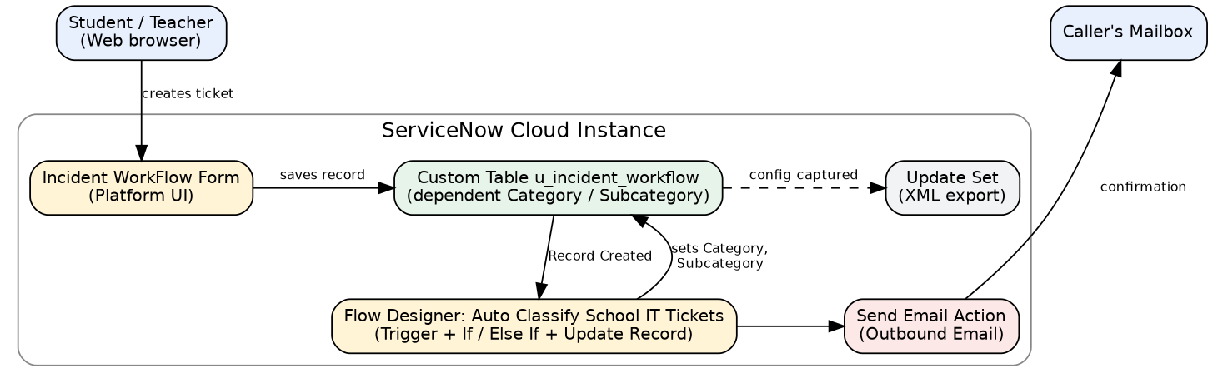

Table-1 : Components & Technologies:
S.No | Component | Description | Technology
 | User Interface | Incident WorkFlow form in ServiceNow where the student enters Caller and Short Description | ServiceNow Platform UI (Form Designer)
 | Application Logic-1 | Trigger: Record Created on Incident WorkFlow table, condition Category is empty | ServiceNow Flow Designer
 | Application Logic-2 | If / Else If conditions check keywords in Short Description and Update Record sets Category and Subcategory | Flow Designer – Flow Logic and Update Record action
 | Application Logic-3 | Sends confirmation email to the Caller's email address | Flow Designer – Send Email action
 | Database | Custom table u_incident_workflow with fields Number, Caller, Category, Subcategory, Short Description, Description, State, Assigned group, Assigned to | ServiceNow table (auto-number INC prefix)
 | Cloud Database | Table data stored in the ServiceNow cloud instance | ServiceNow instance database
 | File Storage | No file attachments; project configuration exported as update set XML file | Local file system (downloaded XML)
 | External API-1 | Not used | –
 | External API-2 | Not used | –
 | Machine Learning Model | Not used; classification is keyword-based, no-code | –
 | Infrastructure (Server / Cloud) | Application is built and run on the ServiceNow cloud instance; no local server required | ServiceNow Cloud (Global application scope)

Table-2: Application Characteristics:
S.No | Characteristics | Description | Technology
 | Open-Source Frameworks | No open-source framework; built with ServiceNow low-code / no-code tools | ServiceNow Flow Designer
 | Security Implementations | Role-based access control (ACL) on the custom table; mandatory Caller and Short Description fields | ServiceNow ACLs, roles
 | Scalable Architecture | New keywords / categories added with extra Else If branches and choices without scripting | Flow Designer, choice lists
 | Availability | Cloud-hosted instance; flow runs automatically on every new ticket | ServiceNow cloud platform
 | Performance | Flow triggers only when Category is empty and runs at ticket creation, so classification is immediate | Flow Designer trigger condition

References:
https://c4model.com/
https://developer.ibm.com/patterns/online-order-processing-system-during-pandemic/
https://www.ibm.com/cloud/architecture
https://aws.amazon.com/architecture
https://medium.com/the-internal-startup/how-to-draw-useful-technical-architecture-diagrams-2d20c9fda90d

